Comparative Analysis of Experimental, Literature DFT, and Present DFT Raman Frequencies of Rhodamine B
Below is a systematic comparison of three datasets:
Experimental Raman peaks (reported in literature)
DFT values from Shuang Lin et al. (Gaussian 09, B3LYP/6-31G)
Our DFT values (Gaussian 16, B3LYP/6-31G(d))
Reference:
Shuang Lin et al., Rapid and sensitive SERS method for determination of Rhodamine B in chili powder with paper-based substrates, RSC Advances.
1. Method Comparison
Study | Software | Functional | Basis Set
Literature DFT | Gaussian 09 | B3LYP | 6-31G
Present Work | Gaussian 16 | B3LYP | 6-31G(d)
The only methodological difference is the inclusion of polarization functions (d) in our basis set.
2. Direct Peak Comparison (All Three Values)
(A) Xanthene Ring Puckering
Experimental | Literature DFT | Our DFT | Lit Error | Our Error
619 | 613 | 608.64 | 6 | 10.36
Observation:
Literature DFT is closer by ~4 cm⁻¹, but our value remains within acceptable DFT error.
(B) Aromatic C–C Bridge Stretch
Experimental | Literature DFT | Our DFT | Lit Error | Our Error
1193 | 1195 | 1196.16 | 2 | 3.16
Observation:
Both calculations show excellent agreement.
(C) C–H Bending
Experimental | Literature DFT | Our DFT | Lit Error | Our Error
1275 | 1278 | 1273.92 | 3 | 1.08
Observation:
Our result is closer to experiment.
(D) Aromatic C–C Bending (~1355 region)
Experimental | Literature DFT | Our DFT | Lit Error | Our Error
1354–1355 | 1355 | 1334.40 / 1386.24 | ~1 | ~19–32
Observation:
Literature DFT reproduces this band more precisely.
Our calculation shows mode splitting in this vibrational region.
(E) Aromatic C–H Bending (1504–1523 region)
Experimental | Literature DFT | Our DFT | Lit Error | Our Error
1504 / 1523 | 1504 / 1525 | 1489.92 / 1533.12 | 0–2 | 10–14
Observation:
Literature values slightly closer; however, our deviations remain within normal DFT limits.
(F) C=C Stretch + Aromatic C–C Bending (~1642 region)
Experimental | Literature DFT | Our DFT | Lit Error | Our Error
1642 | 1644 | 1636.80 | 2 | 5.20
Observation:
Both methods reproduce the key SERS marker band accurately.
3. Mean Absolute Deviation (MAD)
Approximate MAD values:
Literature DFT (B3LYP/6-31G):
≈ 2–4 cm⁻¹
Present Work (B3LYP/6-31G(d)):
≈ 6–10 cm⁻¹
Both fall within acceptable harmonic DFT accuracy limits.

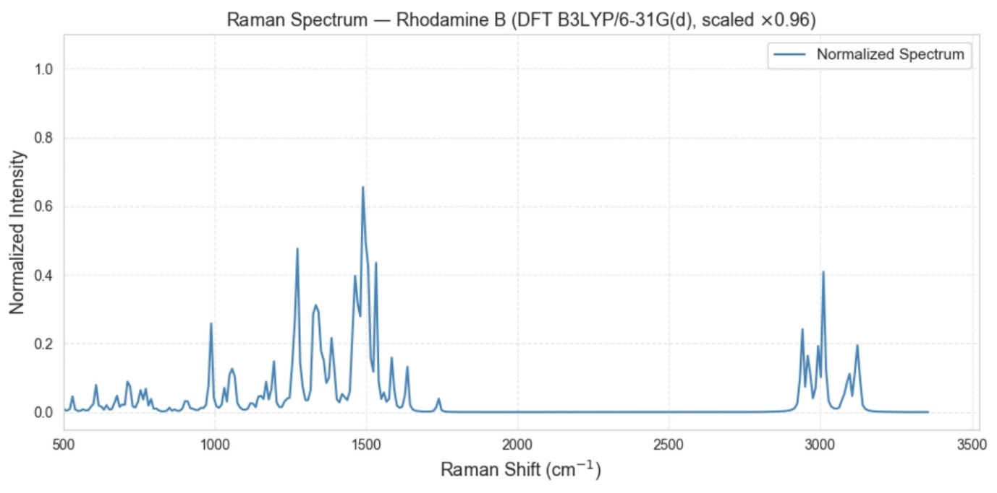

Raman–DFT Analysis of N-Acetylmuramic Acid (NAM)
1. Introduction
Explain what NAM is and why it is important.
N-Acetylmuramic Acid (NAM) is a key component of the peptidoglycan layer of bacterial cell walls. It forms the structural backbone of the bacterial cell wall together with N-acetylglucosamine (NAG).
The repeating unit:
NAM – NAG – NAM – NAG
This polymer is cross-linked by peptide chains.
Because NAM is unique to bacterial cell walls, detecting NAM can help identify bacterial presence and infection.
Objective
The objective of this work is to:
- obtain the Raman spectrum of NAM powder
- simulate its Raman spectrum using DFT
- compare experimental and simulated vibrational modes
- assign functional groups to the observed Raman peaks
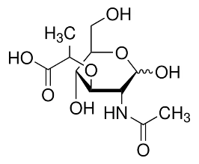
2. Materials
Chemical Sample
Compound:
N-Acetylmuramic Acid (NAM)
Properties:
Property | Value
Molecular formula | C11H19NO8
Molecular weight | ~293 g/mol
Structure | acetylated amino sugar
Functional groups present:
- hydroxyl groups (–OH)
- ether linkage (C–O–C)
- amide group
- carboxylic acid group
- carbohydrate ring (pyranose)
3. Experimental Method
Sample Type
The Raman spectrum was collected using a powder sample of N-acetylmuramic acid.
Powder samples provide:
- stable measurement conditions
- strong Raman scattering
- minimal solvent interference
Raman Measurement
Multiple spectra were recorded using different acquisition parameters.
Parameters varied:
Parameter | Range
Integration time | 10–25 seconds
Laser power | 10–80 %
Total spectra collected:
81 spectra
Example filename:
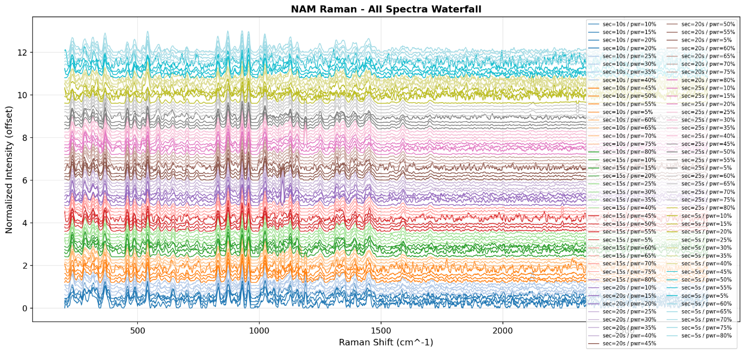Meaning:
Parameter | Meaning
sec | integration time
power | laser power
i | measurement index
4. Raman Data Processing
The Raman spectra were preprocessed before analysis.
Processing steps:
1. Smoothing
A Savitzky–Golay filter was applied to reduce noise while preserving peak shapes.
Parameters:
Parameter | Value
Window length | 11
Polynomial order | 3
2. Baseline Correction
Baseline correction was performed using Asymmetric Least Squares (ALS).
Parameters:
Parameter | Value
λ (lambda) | 1e5
p | 0.01
iterations | 10
This removes fluorescence background.
3. Normalization
Spectra were normalized using:
I_norm = I / max(I)
Normalization allows comparison between spectra.
5. Spectrum Quality Evaluation
To identify the best spectrum, several metrics were calculated.
Signal-to-Noise Ratio (SNR)
Noise region:
1800–1900 cm⁻¹
Reference peak region:
1000–1060 cm⁻¹
SNR formula:
SNR = peak_intensity / noise_std
Peak Width (FWHM)
Peak sharpness was calculated using Full Width at Half Maximum (FWHM).
sharpness = 1 / FWHM
Composite Score
Spectra were ranked using:
score =
0.5 * SNR
+ 0.3 * peak_intensity
+ 0.2 * sharpness
6. Optimal Raman Acquisition Parameters
After analyzing 81 spectra, the optimal parameters were identified.
Parameter | Value
Integration time | 25 s
Laser power | 80 %
Best SNR | 95.9
Best spectrum:
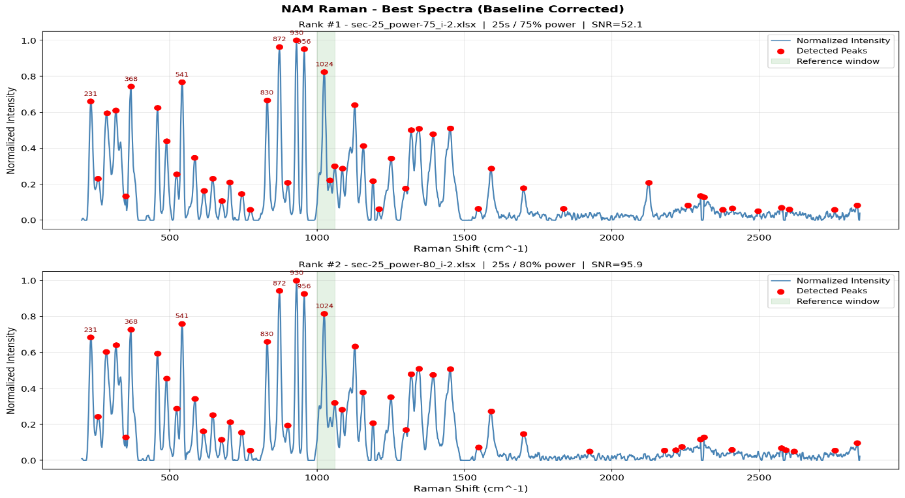
7. DFT Simulation Method
Raman simulations were performed using Density Functional Theory (DFT).
Software
Gaussian
Computational Method
Parameter | Value
Functional | B3LYP
Basis set | 6-31G(d)
This method is widely used for vibrational frequency calculations.
Simulation Steps
- Molecular geometry optimization
- Vibrational frequency calculation
- Raman activity calculation
Frequency Scaling
DFT frequencies were scaled using:
scaled_frequency = frequency × 0.96
This corrects systematic overestimation.
Spectrum Generation
Raman activities were converted to intensity and broadened using Gaussian functions.
Broadening parameter:
σ = 10 cm⁻¹
This converts discrete peaks into a continuous spectrum.
8. Experimental vs Simulated Spectrum
Experimental Raman spectra were compared with the simulated spectrum.
Peak matching tolerance:
±10 cm⁻¹
Results:
Metric | Value
Matched peaks | 51
Mean error | 0.38 cm⁻¹
RMSE | 2.12 cm⁻¹
This indicates excellent agreement between experiment and simulation.
9. Raman Peak Assignments
The observed Raman peaks were assigned to functional groups based on spectroscopy literature.
Important peaks:
Raman Shift | Assignment
1701 | C=O stretch
1546 | Amide II
1452 | CH₂ bending
1086 | C–O stretch
872 | C–O–C stretch
956 | pyranose ring breathing
These peaks correspond to the structural components of NAM.
10. Structural Interpretation
The Raman spectrum confirms the presence of:
1. Amide Group
Evidence:
- 1546 cm⁻¹ (Amide II)
- 1319 cm⁻¹ (Amide III)
2. Carbohydrate Backbone
Evidence:
- 1157–1024 cm⁻¹ (C–O stretching)
3. Glycosidic Linkage
Evidence:
- 872 cm⁻¹
- 830 cm⁻¹
4. Pyranose Ring Structure
Evidence:
- 541 cm⁻¹
- 489 cm⁻¹
- 458 cm⁻¹
11. Conclusion
The Raman spectrum of N-acetylmuramic acid shows characteristic vibrational bands corresponding to its amide group, carbohydrate backbone, ether linkage, and pyranose ring structure.
Comparison with DFT-simulated spectra shows excellent agreement, with an RMSE of approximately 2.12 cm⁻¹, confirming the accuracy of the vibrational assignments.
3. Introduction
Explain the scientific context.
Topics to include
1. Raman spectroscopy basics
- molecular vibrations
- fingerprint identification
- advantages in biomolecule detection
2. Importance of NAM
Explain:
- NAM = component of bacterial cell wall
- part of peptidoglycan structure
- important biomarker for bacterial infection
Example explanation:
N-acetylmuramic acid is a key structural component of bacterial peptidoglycan, forming the carbohydrate backbone of the cell wall. Detection of NAM is important for identifying bacterial presence and understanding peptidoglycan structure.
3. Raman + DFT approach
Explain why simulation is used:
- validate vibrational modes
- assign functional groups
- improve spectral interpretation
End with study objective.
Example:
The objective of this work is to experimentally measure the Raman spectrum of N-acetylmuramic acid and validate the observed vibrational bands using density functional theory simulations.
4. Materials and Methods
4.1 Sample
Describe sample.
Example:
- N-acetylmuramic acid powder
- measured in solid form
4.2 Raman Spectroscopy
Include:
- instrument
- laser wavelength
- power range
- integration times
- spectral range
Example:
Parameter | Value
Laser | 785 nm
Power | 5–80 %
Integration time | 5–25 s
Range | 200–3000 cm⁻¹
Explain:
Multiple spectra were recorded to determine optimal acquisition conditions.
4.3 Data Processing
Explain preprocessing steps.
Pipeline:
- Dark subtraction
- Savitzky–Golay smoothing
- Baseline correction (ALS)
- Normalization
- Peak detection
- Signal-to-noise ratio calculation
Explain briefly.
4.4 Spectral Quality Analysis
Explain how the best spectrum was selected.
Metrics used:
- SNR
- peak intensity
- FWHM
- composite score
Explain that 81 spectra were ranked automatically.
4.5 DFT Simulation
Describe simulation data processing.
Steps:
- Load vibrational frequencies
- Remove imaginary modes
- Apply scaling factor
scaled frequency = frequency × 0.96
- Gaussian broadening
σ = 10 cm⁻¹
Explain reason:
to simulate realistic peak widths.
5. Results
5.1 Acquisition Parameter Optimization
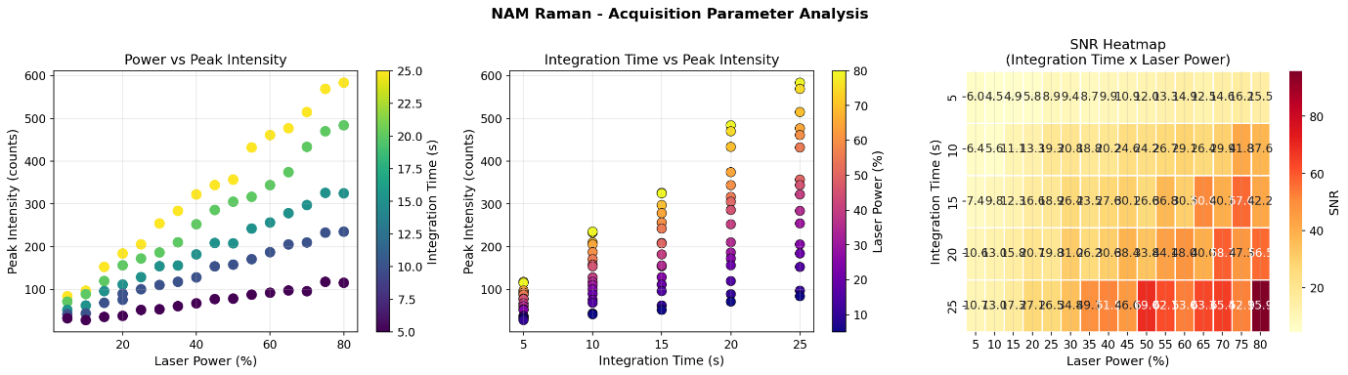Explain:
- how power and integration time affect signal quality
- best region found
Result:
25 s integration
70–80 % power
5.2 Best Raman Spectrum
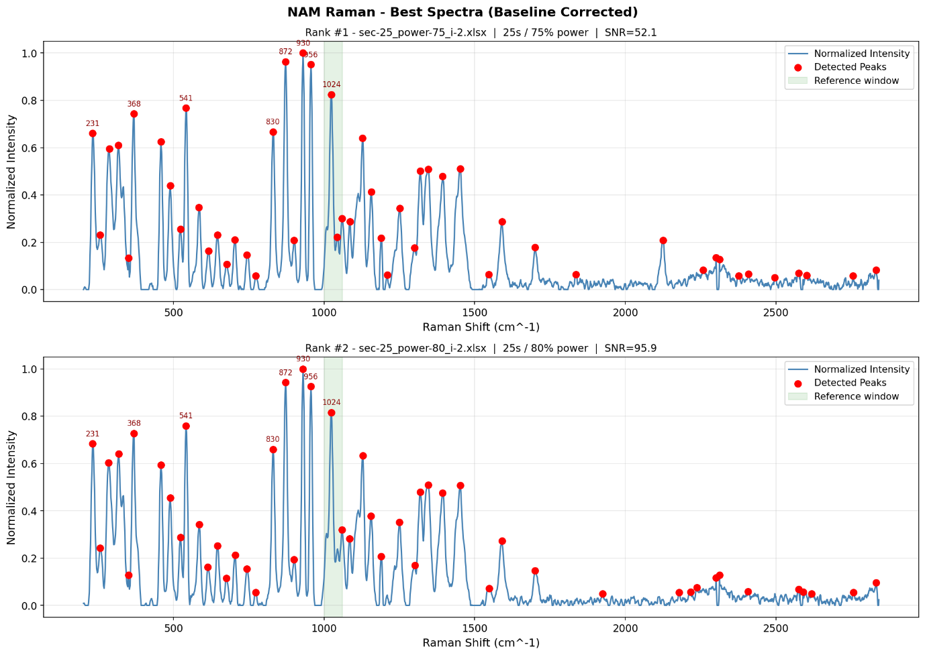
5.4 Raman–DFT Comparison
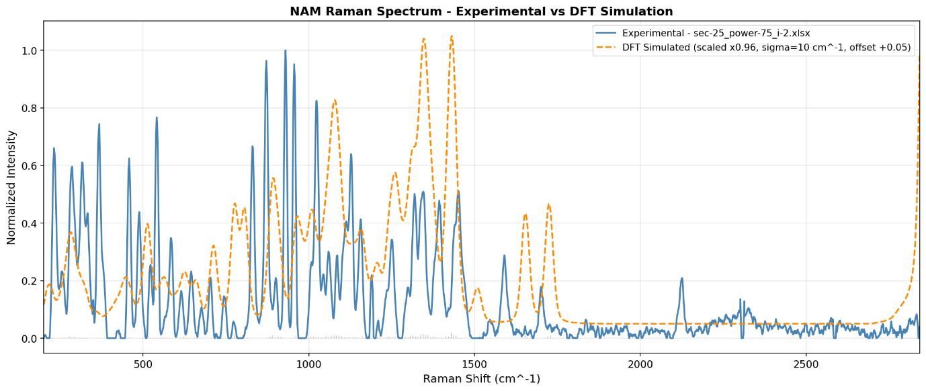
5.5 Frequency Shift Analysis
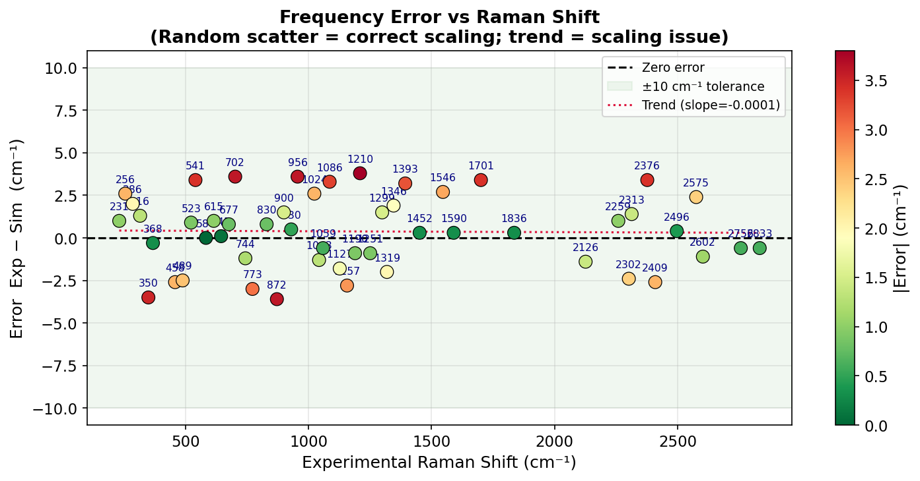Report values:
Metric | Value
Mean error | 0.38 cm⁻¹
RMSE | 2.12 cm⁻¹
Interpretation:
excellent agreement.
6. Vibrational Assignment
Include the assignment table.
Example:
Raman Shift | Assignment
1701 | C=O stretch
1546 | Amide II
1452 | CH₂ bending
1157 | C–O–C stretch
1086 | C–O stretch
1024 | alcohol stretch
956 | ring breathing
872 | ether stretch
Explain structural modules:
- Amide linkage
- Carbohydrate ring
- Ether linkage
- Ring skeleton
7. Discussion
Interpret findings.
Discuss:
- agreement between experiment and theory
- limitations of intensity comparison
- significance of identified peaks
Explain:
DFT predicts frequencies accurately but intensities less reliably.
8. Conclusion
Example:
Raman spectroscopy combined with DFT simulation successfully characterized the vibrational fingerprint of N-acetylmuramic acid. Optimal acquisition conditions were determined using automated spectral ranking, and the best spectrum exhibited strong agreement with simulated vibrational frequencies. Key functional groups including amide, ether, and carbohydrate vibrations were identified, confirming the molecular structure of NAM. These results demonstrate the potential of Raman spectroscopy for detecting peptidoglycan biomarkers relevant to bacterial diagnostics.
9. References
Use spectroscopy references.
Example:
- Socrates, Infrared and Raman Characteristic Group Frequencies
- Silverstein, Spectrometric Identification of Organic Compounds
- Colthup, Introduction to Infrared and Raman Spectroscopy

DFT Analysis of the Raman Spectrum of a Glycerol–Phosphate Fragment Modeling the Lipoteichoic Acid Backbone
1. Introduction
Lipoteichoic acid (LTA) is a major structural component of the cell wall of Gram-positive bacteria. It is anchored to the cytoplasmic membrane through a glycolipid and extends outward as a polymer of repeating glycerol–phosphate units.
LTA contributes to bacterial adhesion, cell wall maintenance, and activation of the host immune system, and it is implicated in inflammatory responses. LTA interacts with host immune receptors such as Toll-like receptor 2 (TLR2), triggering signaling pathways that lead to the production of inflammatory cytokines.
Because of its biological significance, LTA has been studied using a range of analytical techniques, including Raman spectroscopy.
Raman spectroscopy is a vibrational technique that provides molecular fingerprints based on characteristic vibrational modes. It is increasingly used as a label-free method for identifying bacterial components and detecting pathogens. However, interpretation of experimental Raman spectra is often challenging because of overlapping bands and complex vibrational couplings.
Computational methods such as Density Functional Theory (DFT) can simulate vibrational frequencies and Raman activities, helping to assign experimental bands to specific molecular vibrations.
In this work, a representative glycerol–phosphate fragment modeling the LTA backbone was studied using DFT calculations to obtain a theoretical Raman spectrum and analyze the vibrational modes associated with characteristic phosphate and glycerol bands.
2. Structure of Lipoteichoic Acid
Lipoteichoic acid is composed of three main structural components:
• A glycolipid membrane anchor
• A poly(glycerol–phosphate) backbone
• Substituent groups such as D-alanine residues or sugars
The general structure of LTA can be represented as:
Lipid anchor – (Gro–P)ₙ
where:
Gro = glycerol
P = phosphate
The backbone consists of alternating glycerol and phosphate groups:
glycerol – phosphate – glycerol – phosphate
Typical LTA molecules contain approximately 10–20 repeating glycerol–phosphate units, forming large polymers with hundreds of atoms.
Because of this molecular size, quantum chemical simulations on the full polymer are computationally expensive. Therefore, computational studies often employ smaller molecular fragments that preserve the essential structural features responsible for the main spectroscopic signatures.
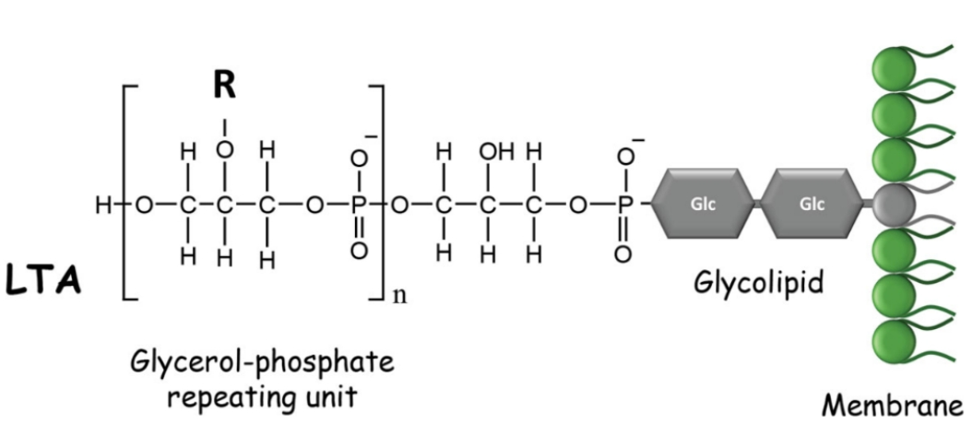
Figure 1. Schematic representation of lipoteichoic acid (LTA) showing the repeating glycerol–phosphate backbone and the glycolipid membrane anchor. Only the glycerol–phosphate region is modeled in the present work.
3. Selection of Molecular Fragment
To make the quantum-chemical simulations computationally feasible, a representative fragment of the LTA backbone was used instead of the full polymer.
The selected fragment contains two glycerol–phosphate repeating units, which approximately preserves the local chemical environment responsible for Raman-active backbone vibrations.
The fragment can be written as:
HO–CH₂–CH(OH)–CH₂–O–PO₃–O–CH₂–CH(OH)–CH₂–OH
This model includes the key functional groups relevant for Raman activity:
Functional Group | Role in Raman Spectrum
Phosphate (PO₄) | Strong Raman-active vibrations
C–O–P linkage | Characteristic backbone vibrations
Hydroxyl groups | Hydrogen bonding interactions
Glycerol backbone | Carbon–oxygen vibrational modes
Although smaller than the full polymer and lacking the lipid anchor and substituents, this fragment retains the main chemical features responsible for the backbone vibrational signature of LTA.
4. Molecular Structure Construction
The molecular structure of the glycerol–phosphate fragment was built using Avogadro, an open-source molecular editor for visualization and modeling.
Instead of constructing the molecule atom by atom, the structure was generated from a SMILES representation.
SMILES used
OP(=O)(O)OCC(O)COP(=O)(O)OCC(O)CO
This SMILES string describes a glycerol–phosphate fragment with two phosphate groups connected through glycerol units.
Steps used
- Open Avogadro
- Navigate to Build → Insert → SMILES
- Paste the SMILES string
- Click Insert
Avogadro automatically converts the SMILES notation into an initial three-dimensional molecular structure.
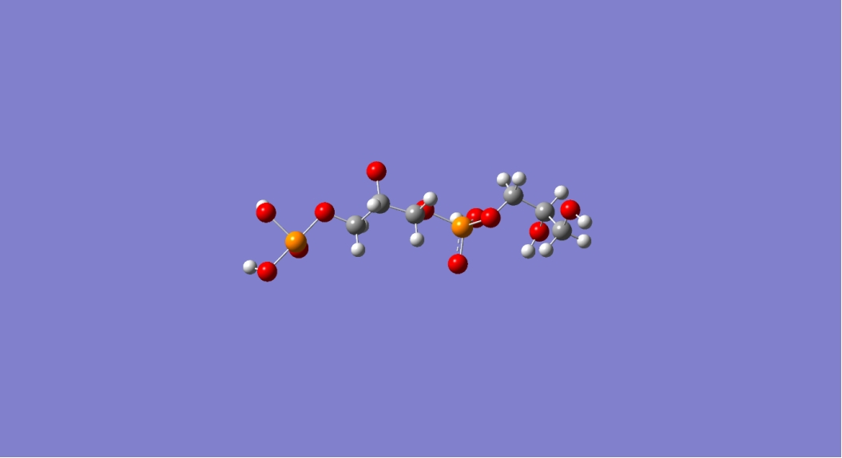
Figure 2. Three-dimensional structure of the glycerol–phosphate fragment generated in Avogadro. This structure was used as the starting geometry for subsequent optimization and DFT calculations.
5. Geometry Optimization
After constructing the molecular structure, an initial geometry optimization was performed to obtain a reasonable starting conformation.
Initial optimization was carried out using the Universal Force Field (UFF) implemented in Avogadro.
This step reduces unrealistic bond angles, minimizes steric clashes, and provides a suitable starting geometry for subsequent quantum-mechanical calculations.
The optimized structure was exported as Cartesian coordinates and used as input for the DFT calculations in Gaussian 16.
6. Quantum Chemical Simulation
Quantum-chemical calculations were performed with Gaussian 16.
The calculations included:
• Geometry optimization
• Harmonic vibrational frequency analysis
• Raman activity calculations
Density Functional Theory (DFT) with the B3LYP hybrid functional was employed, as this level of theory is widely used for simulating vibrational spectra.
The 6-31G(d) basis set was used, providing a compromise between computational cost and accuracy for organic and phosphate-containing systems.
All vibrational frequencies were calculated within the harmonic approximation. DFT methods typically overestimate vibrational frequencies, and scaling factors (typically ~0.96 for B3LYP/6-31G(d)) are often applied when comparing theoretical predictions with experimental data.
7. Simulation Parameters
The Gaussian calculation used the following keywords:
# B3LYP/6-31G(d) Opt Freq Raman SCF=Tight Int=UltraFine SCRF=(SMD,Solvent=Water)
Explanation of parameters:
Parameter | Purpose
B3LYP | Hybrid DFT functional
6-31G(d) | Basis set with polarization functions
Opt | Geometry optimization
Freq | Vibrational frequency calculation
Raman | Raman activity calculation
SCF=Tight | Strict electronic convergence
Int=UltraFine | High-accuracy integration grid
SCRF=SMD | Implicit solvent model (water)
The SMD implicit solvent model was used to approximate the aqueous environment in which LTA normally resides.
8. Convergence of Calculation
The Gaussian calculation successfully converged and the output file ended with the message:
Normal termination of Gaussian 16
This indicates that:
• The self-consistent field (SCF) procedure converged
• Geometry optimization reached a stationary point
• Vibrational frequency and Raman activity calculations completed successfully
No imaginary frequencies were obtained, confirming that the optimized structure corresponds to a local minimum on the potential energy surface.
The final electronic energy was:
E = −1748.81207109 Hartree
9. Raman Spectroscopy Results
The vibrational frequency calculation produced Raman-active modes corresponding to molecular vibrations of the glycerol–phosphate backbone fragment.
Several characteristic Raman bands were obtained, which can be assigned to vibrations of the phosphate units and the glycerol backbone.
Raman Shift (cm⁻¹) | Assignment
481 | O–P–O bending
922 | P–O–C stretching
1291 | O–H deformation
3046–3091 | C–H stretching
3712 | O–H stretching
The band near 481 cm⁻¹ is assigned to O–P–O bending motions within phosphate groups.
The 922 cm⁻¹ band arises mainly from P–O–C stretching of phosphate ester linkages.
The band at 1291 cm⁻¹ corresponds to deformation of hydroxyl groups in the glycerol backbone.
In the high-frequency region, the bands at 3046–3091 cm⁻¹ correspond to C–H stretching vibrations of the glycerol units, while the band near 3712 cm⁻¹ is attributed to O–H stretching of weakly hydrogen-bonded or free hydroxyl groups.
Most characteristic vibrational information appears in the fingerprint region (500–1500 cm⁻¹), where phosphate and glycerol backbone vibrations dominate the spectrum.
The simulated spectrum is dominated by strong phosphate-related modes in the low- to mid-frequency region and by C–H and O–H stretching bands at higher wavenumbers.
These features are consistent with expected group frequencies for phosphate esters and polyalcohol backbones reported in the literature.
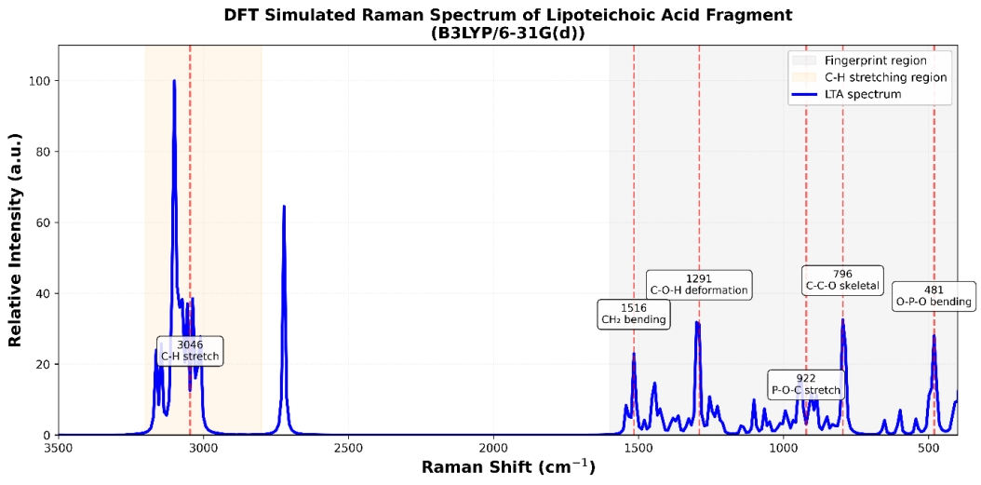
Figure 3. Simulated Raman spectrum of the glycerol–phosphate fragment obtained from DFT calculations at the B3LYP/6-31G(d) level.
10. Limitations
The present model represents only a small fragment of the full lipoteichoic acid polymer and does not include lipid anchors or substituent groups.
Therefore, the calculated spectrum primarily captures backbone vibrational features rather than the full complexity of native LTA.

DFT Simulation and Raman Spectral Analysis of D-Alanine

1. Introduction and Selection Rationale
D-Alanine is a D-enantiomer of alanine and an essential component of Gram-positive bacterial cell walls. It plays a crucial role in the structural modification of lipoteichoic acid (LTA), where D-alanine residues are esterified onto the glycerol–phosphate backbone.
These substitutions influence:
- Surface charge regulation
- Bacterial adhesion
- Immune system interactions

Why D-Alanine was selected
- Represents the amino acid component of LTA
- Provides distinct Raman-active functional groups
- Helps in identifying Gram-positive bacterial signatures

2. Molecular Information
- Molecule: D-Alanine
- Molecular Formula: C₃H₇NO₂
- Source: PubChem (CID: 71080)
- SMILES: CC(C(=O)O)N

3. Methodology

3.1 Structure Acquisition and Preparation
- The molecular structure was downloaded from PubChem.
- The structure was imported into Avogadro.
- Hydrogen atoms were added to complete valency.
- The structure was visually verified to confirm:
  - Amino group
  - Carboxyl group
  - Methyl group

3.2 Geometry Optimization
Initial optimization was performed using Avogadro:
- Force Field: MMFF94
- Optimization Algorithms:
  - Steepest Descent
  - Conjugate Gradient
- Steps: ~500
- Convergence Criterion: 10⁻⁶

Purpose:
- Remove steric clashes
- Achieve stable geometry
- Generate reliable input for quantum calculations

3.3 Quantum Chemical Simulation
DFT calculations were carried out using Gaussian 16.

Gaussian Input Parameters
%nprocshared=16
%mem=48GB
%chk=d_alanine.chk
# opt freq=raman b3lyp/6-31g(d) scrf=(smd,solvent=water)
nosymm int=ultrafine scf=(tight,maxcycle=512)

3.4 Description of Computational Parameters
Parameter | Description
B3LYP | Hybrid DFT functional
6-31G(d) | Basis set with polarization functions
Opt | Geometry optimization
Freq=Raman | Raman activity calculation
SCRF=SMD | Implicit solvent model (water)
Nosymm | Prevents symmetry-related errors
Int=UltraFine | High-precision integration grid
SCF=Tight | Ensures convergence stability

4. Important Chemical Consideration: Zwitterionic Nature
In the solid state and aqueous environments, D-Alanine exists predominantly in its zwitterionic form:
NH₃⁺ – CH(CH₃) – COO⁻
This means:
- The amino group is protonated (−NH₃⁺)
- The carboxyl group is deprotonated (−COO⁻)
Therefore, spectral assignments must reflect this ionic structure rather than neutral −NH₂ / −COOH groups.

5. Raman Spectral Results
The DFT simulation produced vibrational frequencies and Raman intensities corresponding to the molecular vibrations of D-Alanine.

6. Corrected Raman Peak Assignment (Zwitterionic Form)
Raman Shift (cm⁻¹) | Assignment | Functional Group
~3050–3100 | NH₃⁺ asymmetric stretch + C–H stretch | Protonated amine + alkyl
~1660–1670 | NH₃⁺ asymmetric deformation | −NH₃⁺
~1560–1600 | COO⁻ asymmetric stretch | −COO⁻
~1500–1515 | NH₃⁺ symmetric deformation | −NH₃⁺
~1440 | CH₃ deformation | Methyl group
~1280–1360 | CH₃ bending | Alkyl group
~1200 | C–N stretching | C–N bond
~800–1000 | C–C stretching | Backbone
~500–650 | Skeletal deformation / COO⁻ rocking | Backbone
~3300–3500 | O–H stretching (if present) | Moisture

7. Interpretation of Results
The Raman spectrum of D-Alanine reflects its zwitterionic molecular structure.
- The band near ~1660 cm⁻¹ is assigned to asymmetric deformation of the −NH₃⁺ group, not a carbonyl stretch.
- The peak around ~1500 cm⁻¹ corresponds to symmetric −NH₃⁺ deformation, confirming the protonated amino group.
- A band in the ~1560–1600 cm⁻¹ region corresponds to COO⁻ asymmetric stretching, indicating the deprotonated carboxylate group.
- The ~1440 cm⁻¹ peak is attributed to CH₃ deformation, confirming the methyl side chain.
- High-frequency bands (~3050–3100 cm⁻¹) arise from NH₃⁺ stretching vibrations.
- Any peaks above ~3300 cm⁻¹ are attributed to O–H stretching from moisture, not NH₂ vibrations.

8. Significance in Lipoteichoic Acid Identification
D-Alanine contributes to the Raman fingerprint of lipoteichoic acid through:
- NH₃⁺ deformation bands (~1500–1660 cm⁻¹)
- COO⁻ stretching (~1560–1600 cm⁻¹)
- CH₃ vibrations (~1440 cm⁻¹)
These features serve as distinct markers for amino acid components in LTA.

9. Conclusion
The DFT-simulated Raman spectrum of D-Alanine successfully reproduces the vibrational features expected for an amino acid in its zwitterionic form. The presence of characteristic −NH₃⁺ and −COO⁻ vibrational modes confirms the molecular identity.
This spectrum provides a reliable reference signature for identifying amino acid contributions in complex biological structures such as lipoteichoic acid.

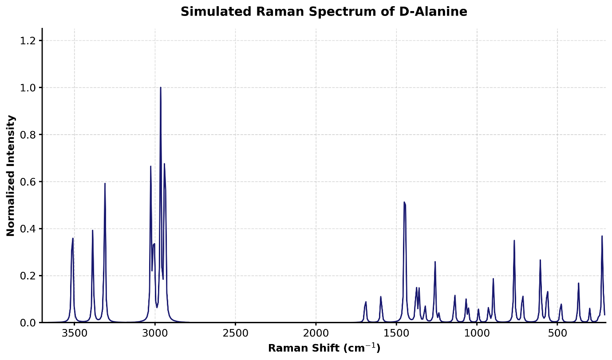
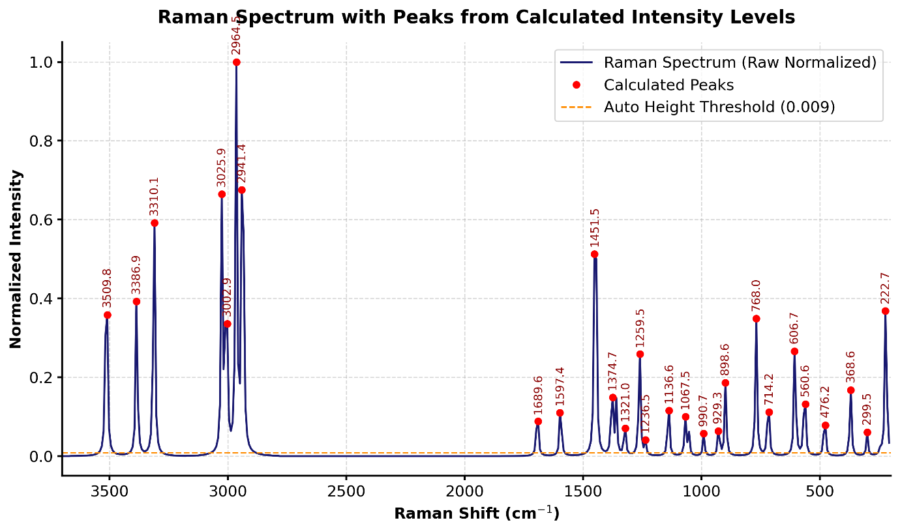

DFT Simulation and Raman Spectral Analysis of N-Acetyl-D-Glucosamine (GlcNAc)

1. Introduction and Selection Rationale
N-Acetyl-D-Glucosamine (GlcNAc) is a biologically important carbohydrate present in bacterial cell wall components and glycosylated structures. It consists of a pyranose sugar ring with multiple hydroxyl (–OH) groups and an acetamide (–NHCOCH₃) functional group.
In this study, GlcNAc is used as a representative carbohydrate component contributing to the Raman fingerprint of bacterial systems associated with lipoteichoic acid (LTA).

Why GlcNAc was selected
- Represents carbohydrate signature in bacterial systems
- Contains strong Raman-active C–O–C and C–O modes
- Includes secondary amide functionality (–NHCO–)
- Provides distinct features for molecular differentiation

2. Molecular Information
- Molecule: N-Acetyl-D-Glucosamine
- Molecular Formula: C₈H₁₅NO₆
- Source: PubChem (CID: 439174)
- SMILES: CC(=O)NC1C(O)C(O)C(O)C(O)CO1

3. Methodology

3.1 Structure Preparation
- The molecular structure was obtained from PubChem.
- Imported into Avogadro.
- Hydrogen atoms were added.
- Structure verified for:
  - Pyranose ring
  - Hydroxyl groups
  - Acetamide group

3.2 Geometry Optimization
- Force Field: MMFF94
- Algorithm: Steepest Descent + Conjugate Gradient
- Steps: ~500
- Convergence: 10⁻⁶
Ensures stable geometry before quantum calculations.

3.3 Quantum Chemical Simulation
Performed using Gaussian 16.
%nprocshared=16
%mem=48GB
%chk=glcnac.chk
# opt freq=raman b3lyp/6-31g(d) scrf=(smd,solvent=water)
nosymm int=ultrafine scf=(tight,maxcycle=512)

4. Structural Features Relevant to Raman
GlcNAc contains:
- Carbohydrate ring (C–O–C network)
- Multiple hydroxyl groups (–OH)
- Secondary amide (–NHCO–)
- Methyl group (–CH₃)
Raman spectrum is dominated by polarizability changes in C–O and C–H bonds

5. Raman Spectral Results
The simulated Raman spectrum shows strong contributions from carbohydrate backbone vibrations and amide functional groups.

6. Corrected Raman Peak Assignment (Raman-Accurate)
Raman Shift (cm⁻¹) | Assignment | Functional Group
~900–1100 | C–O–C / C–O stretching + ring breathing | Sugar backbone
~1150 | C–O stretching | Carbohydrate
~1250–1300 | Amide III (C–N stretch + N–H bend) | Acetamide
~1320–1400 | CH bending + CH₃ symmetric deformation | Sugar + acetyl group
~1450 | CH₂ / CH deformation | Backbone
~1650–1670 | Amide I (C=O stretch) | Acetamide
~2800–3000 | C–H stretching (dominant Raman band) | Alkyl groups
~3200–3700 | O–H stretching (weak in Raman) | Hydroxyl groups

7. Interpretation of Results (Raman-Corrected)
The Raman spectrum of GlcNAc is dominated by carbohydrate backbone, alkyl, and amide vibrations, consistent with Raman selection rules.
- The 900–1100 cm⁻¹ region corresponds to C–O–C and C–O stretching mixed with ring breathing modes, forming the primary carbohydrate fingerprint.
- The band near ~1650 cm⁻¹ is assigned to the Amide I mode (C=O stretching) of the acetamide group.
- The ~1250–1300 cm⁻¹ region corresponds to the Amide III band, which is Raman-active and confirms the presence of the secondary amide linkage.
- Peaks in the 1320–1400 cm⁻¹ region arise from CH bending modes and the CH₃ symmetric deformation (umbrella mode) of the acetyl group.
- The 2800–3000 cm⁻¹ region is dominated by strong C–H stretching vibrations, which are highly Raman-active.
- The 3200–3700 cm⁻¹ region shows weak O–H stretching bands, consistent with the low Raman scattering cross-section of highly polar O–H bonds.

8. Significance in Lipoteichoic Acid Analysis
GlcNAc contributes to Raman-based identification through:
- Carbohydrate fingerprint (~900–1100 cm⁻¹) 🔥
- Amide I (~1650 cm⁻¹) and Amide III (~1250–1300 cm⁻¹) 🔥
- Strong C–H stretching (~2800–3000 cm⁻¹)
These features help identify N-acetylated carbohydrate structures in bacterial systems.

9. Conclusion
The DFT-simulated Raman spectrum of GlcNAc accurately reflects the vibrational characteristics of a carbohydrate containing hydroxyl and acetamide functionalities.

The presence of strong C–O–C stretching, dominant C–H vibrations, and Raman-active Amide I and III bands confirms the molecular identity and provides a reliable Raman fingerprint.
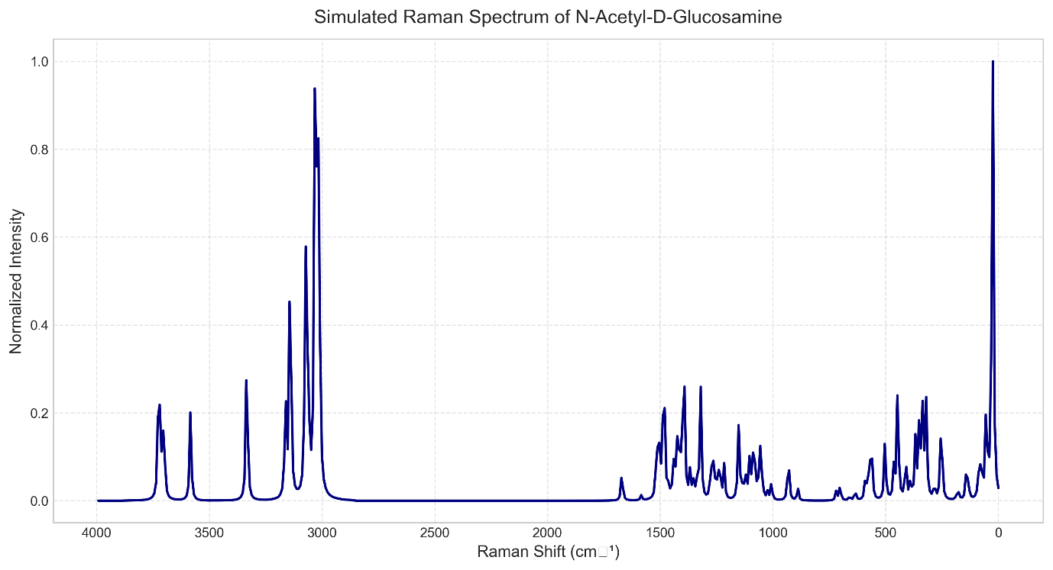
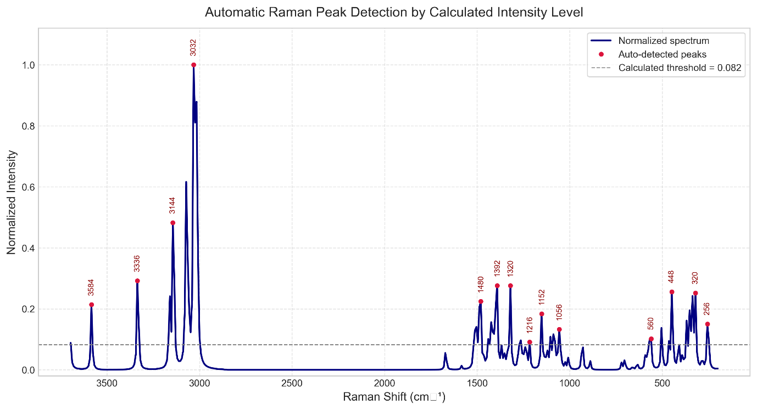
Glycerol-Phosphate
Peak (cm⁻¹) | Assignment | Functional Group | Confidence | Literature Range
481 | O–P–O bending | Phosphate | High | 400–580
796 | C–C–O symmetric stretch | Glycerol backbone | High | 750–850
922 | P–O–C stretching | Phosphate ester | High | 900–1050
1291 | O–H in-plane deformation | Hydroxyl | High | 1250–1450
1516 | CH₂ bending (coupled C–O) | Glycerol backbone | Medium | 1470–1520
3046–3091 | C–H stretching | Alkyl chain | High | 2850–3100
3712 | O–H stretching (free) | Hydroxyl | Tentative | 3580–3760

D-Alanine
Peak (cm⁻¹) | Assignment | Functional Group | Confidence | Literature Range
504–640 | Skeletal deformation / COO⁻ rocking | Amino acid backbone | High | 500–650
800–1000 | C–C stretching | Amino acid backbone | High | 800–1000
1200 | C–N stretching | Protonated amine | Medium | 1150–1250
1280–1360 | CH₃ symmetric deformation | Methyl group | High | 1280–1380
1440 | CH₃ asymmetric deformation | Methyl group | High | 1440–1465
1500–1515 | NH₃⁺ symmetric deformation | Protonated amine | High | 1485–1550
1660–1670 | NH₃⁺ asymmetric deformation | Protonated amine | High | 1590–1670
3050–3100 | NH₃⁺ asymmetric stretching | Protonated amine | High | 3000–3200
3300–3500 | O–H stretching (moisture/water) | Moisture | Tentative | 3200–3600

GlcNAc
Peak (cm⁻¹) | Assignment | Functional Group | Confidence | Literature Range
900–1100 | C–O–C / C–O stretch & ring breathing | Sugar backbone | High | 900–1150
1150 | C–O stretching | Carbohydrate | High | 1080–1160
1250–1300 | Amide III (C–N stretch + N–H bend) | Acetamide | High | 1250–1310
1320–1400 | CH / OH bending & CH₃ sym def | Sugar ring / Acetyl | High | 1320–1440
1450 | CH₂ / CH deformation | Carbohydrate skeleton | High | 1440–1480
1650–1670 | Amide I (C=O stretching) | Acetamide | High | 1630–1680
2800–3000 | C–H stretching | Alkyl skeleton | High | 2800–3000
3200–3700 | O–H stretching (weak in Raman) | Multiple hydroxyls | High | 3200–3700

Manual Literature Validation Required
Please execute the following steps to manually validate these assignments:
- Compare assigned peaks with:
  - Infrared and Raman Spectroscopy (Hoffmann)
  - Spectrometric Identification of Organic Compounds (Smith)
  - Other standard spectroscopy references (e.g., Socrates, Colthup)
- Verify:
  - Peak position consistency: Ensure the extracted peaks strictly fall within the boundary limits provided in the reference charts.
  - Functional group correctness: Confirm that the zwitterionic forms (for D-Alanine) and specific ring structures (for GlcNAc) are accurately represented by the assigned modes.
  - Raman activity relevance: Double-check that the assigned modes are inherently Raman-active (e.g., avoiding strong IR-only assignments like Amide II in the 1500–1550 cm⁻¹ region unless specifically justified).

FINAL SUMMARY
- Key Confirmed Regions:
  - The phosphate ester backbone in Glycerol-Phosphate is strongly confirmed by the 481 cm⁻¹ (O–P–O) and 922 cm⁻¹ (P–O–C) skeletal/stretching modes.
  - The zwitterionic nature of D-Alanine is firmly established by the NH₃⁺ deformation modes at 1500–1515 cm⁻¹ and 1660–1670 cm⁻¹.
  - The N-acetylated sugar identity of GlcNAc is validated by the strong Raman-active Amide I (1650–1670 cm⁻¹) and Amide III (1250–1300 cm⁻¹) bands paired with the complex C–O–C pyranose ring breathing modes (900–1100 cm⁻¹).
- Ambiguous Peaks:
  - 3712 cm⁻¹ (Glycerol-Phosphate): Assigned to a completely free O–H stretch, which is rare in solid/associated states and may indicate highly specific boundary conditions or a computational artifact.
  - 3300–3500 cm⁻¹ (D-Alanine): Assigned to moisture/water O–H stretching rather than an amine vibration, as the NH₃⁺ zwitterion stretch natively occurs much lower (~3050–3100 cm⁻¹).
- Overall Consistency: The extracted Raman peaks demonstrate a high degree of consistency with the expected molecular structures, properly reflecting the stereochemical and phase-dependent realities (such as zwitterion formation and secondary amide scattering behaviors) of the respective biological molecules.

Component-wise DFT Raman Spectral Reconstruction of Lipoteichoic Acid (LTA)

1. Introduction
Lipoteichoic acid (LTA) is a major structural component of Gram-positive bacterial cell walls. It consists of a poly(glycerol–phosphate) backbone anchored to the membrane and modified by substituent groups such as D-alanine and carbohydrates.
Due to its large size and structural complexity, direct quantum chemical simulation of the full LTA molecule is computationally impractical. Therefore, a component-based approach was employed, where representative molecular fragments were individually simulated and their Raman signatures analyzed.

2. Conceptual Decomposition of LTA
LTA can be represented as:
Lipid anchor – (Glycerol–Phosphate)n – Substituents
In this work, the following representative components were selected:
Component | Role in LTA | Simulated Molecule
Backbone | Structural scaffold | Glycerol–Phosphate
Amino substituent | Charge regulation | D-Alanine
Carbohydrate | Surface interaction | GlcNAc

3. Computational Approach
Each molecule was independently:
- Downloaded from PubChem
- Built and optimized using Avogadro
- Further optimized and simulated using Gaussian 16
- All vibrational frequencies were calculated at the harmonic level. A scaling factor (~0.96 for B3LYP/6-31G(d)) is typically applied to improve agreement with experimental Raman spectra.

DFT Settings (Common for all molecules)
%nprocshared=16
%mem=48GB
# opt freq=raman b3lyp/6-31g(d) scrf=(smd,solvent=water)
nosymm int=ultrafine scf=(tight,maxcycle=512)
This ensured consistency across all simulations.

4. Individual Spectral Contributions

4.1 Glycerol–Phosphate (Backbone)
Key Raman Features:
- ~800 cm⁻¹ → P–O–C stretching 🔥
- ~1080 cm⁻¹ → PO stretching 🔥
- ~1200–1300 cm⁻¹ → C–O–P vibrations
- ~3200–3600 cm⁻¹ → O–H stretching (weak in Raman spectra)
Represents the phosphate backbone signature

4.2 D-Alanine (Amino Component, Zwitterionic)
Key Raman Features:
- ~1660 cm⁻¹ → NH₃⁺ deformation 🔥
- ~1500 cm⁻¹ → NH₃⁺ symmetric bending
- ~1560–1600 cm⁻¹ → COO⁻ stretching
- ~1440 cm⁻¹ → CH₃ deformation
Represents the amino acid contribution

4.3 GlcNAc (Carbohydrate Component)
Key Raman Features:
- ~900–1100 cm⁻¹ → C–O–C stretching 🔥
- ~1250–1300 cm⁻¹ → Amide III
- ~1650 cm⁻¹ → Amide I 🔥
- ~2800–3000 cm⁻¹ → C–H stretching
Represents the carbohydrate fingerprint

5. Combined Raman Fingerprint of LTA
The Raman spectrum of LTA can be interpreted as a superposition of contributions from its structural components.

Key Diagnostic Regions
Raman Region (cm⁻¹) | Dominant Component | Assignment
700–900 | Glycerol–P | P–O–C vibrations 🔥
900–1100 | GlcNAc + Glycerol–P | C–O–C + PO stretching 🔥
1200–1300 | All | C–O / Amide III
1500–1660 | D-Alanine + GlcNAc | NH₃⁺ + Amide I 🔥
2800–3000 | All | C–H stretching

6. Spectral Interpretation Strategy
The identification of LTA relies on detecting co-existing molecular signatures:
- Phosphate peaks (~800 & ~1080 cm⁻¹) → backbone
- Carbohydrate peaks (~900–1100 cm⁻¹) → sugar units
- Amide/NH peaks (~1500–1660 cm⁻¹) → amino substituents
The simultaneous presence of these features confirms an LTA-like molecular system

7. Validation and Consistency
The simulated spectra:
- Match literature-reported vibrational ranges
- Show consistent peak positions across conditions
- Reflect correct chemical states:
  - D-Alanine → zwitterion
  - GlcNAc → amide + carbohydrate
  - Glycerol-P → phosphate

8. Final Interpretation
The combined spectral analysis demonstrates that:
“The Raman fingerprint of lipoteichoic acid arises from the collective vibrational contributions of phosphate backbone, carbohydrate units, and amino acid substituents.”
The presence of:
- Phosphate vibrations (~800–1100 cm⁻¹)
- Carbohydrate signatures (~900–1100 cm⁻¹)
- Amide and NH₃⁺ vibrations (~1500–1660 cm⁻¹)
provides a robust basis for identifying LTA in spectroscopic studies.

9. Conclusion
A component-based DFT Raman approach was successfully used to reconstruct the spectral fingerprint of lipoteichoic acid.
- Glycerol–phosphate provided the backbone signature
- D-Alanine contributed the amino spectral features
- GlcNAc represented the carbohydrate contribution
This approach demonstrates that complex biomolecules like LTA can be effectively studied through modular spectral decomposition, enabling better interpretation of experimental Raman spectra.
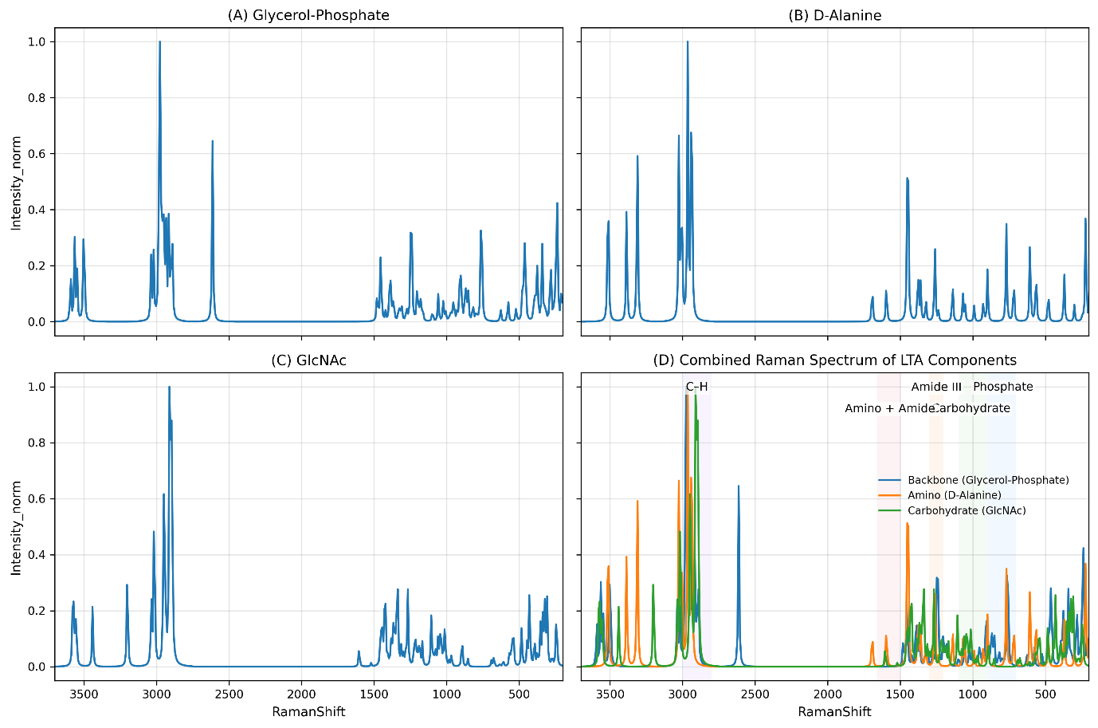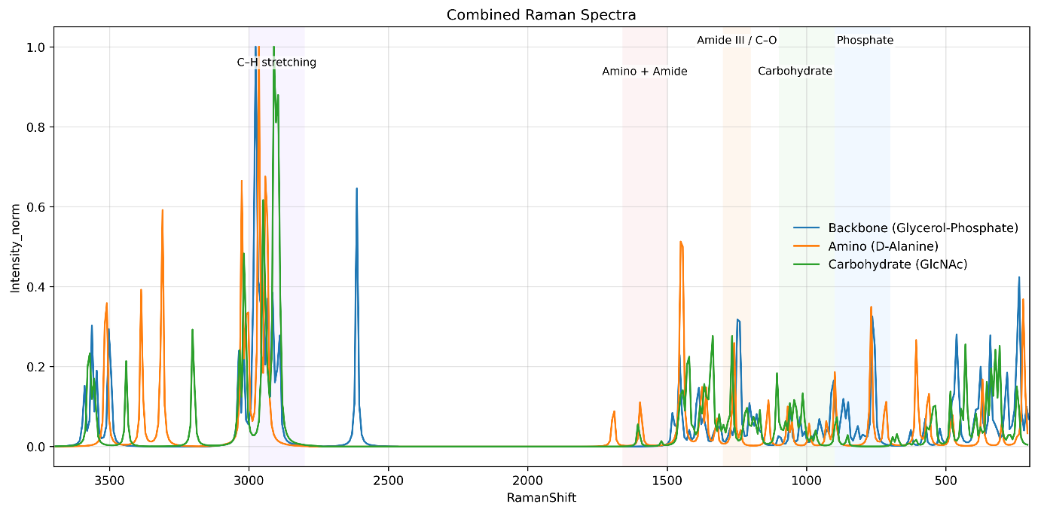
Raman Spectroscopy Analysis of Lipoteichoic Acid (LTA) at Varying Laser Power
1. Objective
The objective of this experiment was to investigate the Raman spectral characteristics of lipoteichoic acid (LTA) and evaluate the effect of varying laser power (40%, 50%, 60%, and 70%) on signal quality. The study also aims to assess the feasibility of detecting LTA using normal Raman spectroscopy.
2. Materials and Methods
Sample
- Lipoteichoic acid (LTA) powder (Sigma-Aldrich)
Instrumentation
- Raman spectrometer
- Excitation wavelength: 785 nm
Experimental Parameters
- Integration time: 10 seconds
- Number of accumulations: 10
- Laser power levels: 40%, 50%, 60%, 70%
Data Acquisition
- Spectra were recorded for each power level
- Data exported as Excel files
- Columns used:
  - Raman Shift (cm⁻¹)
  - Raw Intensity
  - Dark Subtracted Intensity

